do while loop in C

The do while loop is a post tested loop. Using the do-while loop, we can repeat the execution of several parts of the statements. The do-while loop is mainly used in the case where we need to execute the loop at least once. The do-while loop is mostly used in menu-driven programs where the termination condition depends upon the end user.

do while loop syntax

The syntax of the C language do-while loop is given below:

1. **do**{
2. //code to be executed
3. }**while**(condition);

Example 1

1. #include<stdio.h>
2. #include<stdlib.h>
3. **void** main ()
4. {
5. **char** c;
6. **int** choice,dummy;
7. **do**{
8. printf("\n1. Print Hello\n2. Print Javatpoint\n3. Exit\n");
9. scanf("%d",&choice);
10. **switch**(choice)
11. {
12. **case** 1 :
13. printf("Hello");
14. **break**;
15. **case** 2:
16. printf("Javatpoint");
17. **break**;
18. **case** 3:
19. exit(0);
20. **break**;
21. **default**:
22. printf("please enter valid choice");
23. }
24. printf("do you want to enter more?");
25. scanf("%d",&dummy);
26. scanf("%c",&c);
27. }**while**(c=='y');
28. }

Output

1. Print Hello

2. Print Javatpoint

3. Exit

1

Hello

do you want to enter more?

y

1. Print Hello

2. Print Javatpoint

3. Exit

2

Javatpoint

do you want to enter more?

n

Flowchart of do while loop

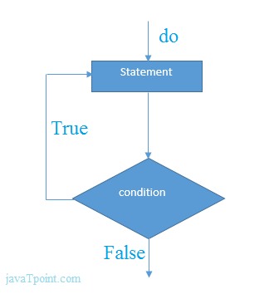

do while example

There is given the simple program of c language do while loop where we are printing the table of 1.

1. #include<stdio.h>
2. **int** main(){
3. **int** i=1;
4. **do**{
5. printf("%d \n",i);
6. i++;
7. }**while**(i<=10);
8. **return** 0;
9. }

Output

1

2

3

4

5

6

7

8

9

10

Program to print table for the given number using do while loop

1. #include<stdio.h>
2. **int** main(){
3. **int** i=1,number=0;
4. printf("Enter a number: ");
5. scanf("%d",&number);
6. **do**{
7. printf("%d \n",(number*i));
8. i++;
9. }**while**(i<=10);
10. **return** 0;
11. }

Output

Enter a number: 5

5

10

15

20

25

30

35

40

45

50

Enter a number: 10

10

20

30

40

50

60

70

80

90

100

Infinitive do while loop

The do-while loop will run infinite times if we pass any non-zero value as the conditional expression.

1. **do**{
2. //statement
3. }**while**(1);